**Project**

**Computer Communication and Networks**

**Name of student: Antonela Alibeaj**

**Name of instructor:Ibrahim Cekiri**

**Task 1: Using the Packet Tracer design the following network topology:**

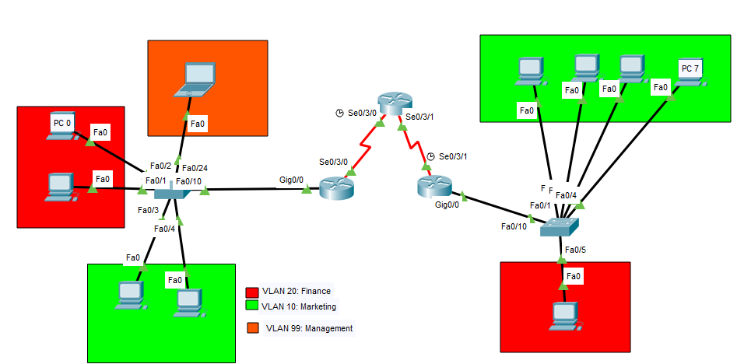

**Task 2: Assign to each of the devices(computers, routers etc) an IP address using as default Network IP address: 192.168.1.0 /24 (Use VLSM for subnetting)**

**Complete the following table:**

|  |  |  |  |  |  |
| --- | --- | --- | --- | --- | --- |
| Network | Hosts | Block | Subnet/CIDR | Mask | Range of IP addresses |
| A | **5(7)** | **8** | **/29** | **255.255.255.248** | **192.168.1.6-192.168.1.31** |
| B | **3(5)** | **8** | **/29** | **255.255.255.248** | **192.168.1.10-192.168.1.11** |
| C | **3(5)** | **8** | **/29** | **255.255.255.248** | **192.168.1.18-192.168.1.19** |
| D | **2(4)** | **4** | **/30** | **255.255.255.252** | **192.168.1.41-1.42** |
| E | **2(4)** | **4** | **/30** | **255.255.255.252** | **192.168.1.24-192.168.1.25** |
| F | **2(4)** | **4** | **/30** | **255.255.255.252** | **192.168.1.29-192.168.1.30** |
| G | **2(4)** | **4** | **/30** | **255.255.255.252** | **192.168.1.241-242** |
|  |  |  |  |  |  |

Place here a screenshot showing the ping test between PC 0 and PC 7

**In this case we do not have a connection between pc0 and pc7.**

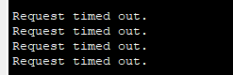 **ping 192.168.1.31**

**Task 3** **– Basic configuration of switches and routers**

Configure switches and routers per the following requirements:

* 1. Hostname of the device as shown in the diagram
  2. Restrict the access to the privileged mode of switch with hashed password ‘ LastChance ’
  3. Restrict the access to the privileged mode of routers with hashed password ‘Identity’
  4. Protect console connection with a shared password(use your city name as a password)
  5. Protect the console and vty terminal lines (for switches and routers)using a local username and password (set as username your name and as password your surname)

*Write down in the Appendix A the commands you’ve used for configuring one of the switches*

**Task 4** **- VLAN and trunk configuration**

1. Based on the information shown in the figure create VLANs.

Place here a screenshot showing the ping test between PC 0 and PC 7

 ping 191.168.1.31

**No connection again !**

Place here in the document the screenshots of the output command which briefly shows the VLANs for both switches.

For Switch1: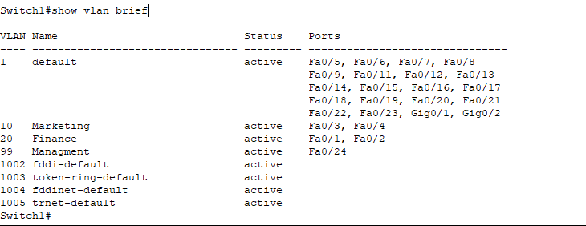

For Switch2: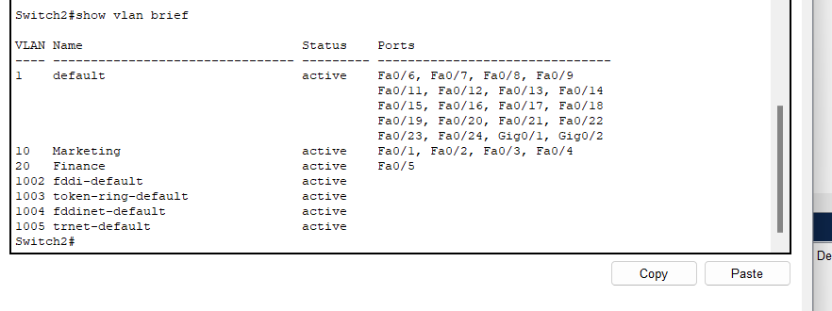

*Write down in the Appendix C the commands you’ve used for configuring one of the switches*

**Task 5** **– Configure the routers in order for PCs 0 and 7 to have connectivity with each other**

Place here a screenshot showing the ping test between PC 0 and PC 7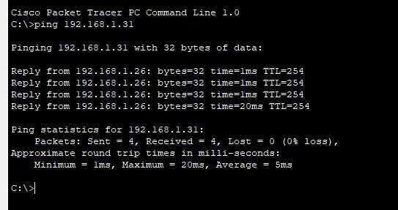

*Write down in the Appendix B the commands you’ve used for configuring the routers*

**Task6 – Configuration of Administrator laptop**

Configure the administrator laptop (IP, VLAN etc.) in order that it can access the switch using telnet and SSH (configure also the VLAN in the switch).

Configure port security for the interface where the laptop is connected, use restrict violation mode.

Place a screenshot of the **show port-security** command for the interface you configured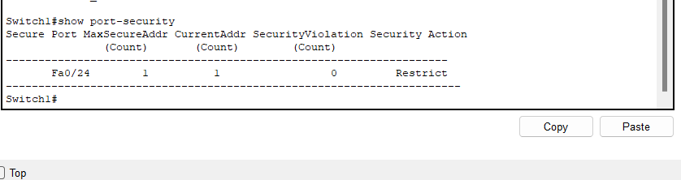

Place a screenshot of the Command Prompt Window showing the laptop accessing the configuration mode of the switch through **telnet** and **ssh .**

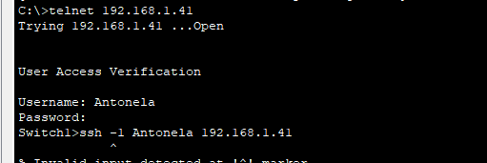

*Write down in the Appendix D the commands you’ve used for configuring switch and router*

**Note:** Save all the configurations of the network as a .pkt file and send it in a zip file.

**Appendix A**

1. Switch>en

Switch#config ter

Switch(config)# hostname switch1

Router>en

Router#config ter

Router(config)# hostname router1

1. switch1(config)# enable secret LastChance

switch1(config)# do copy run start

1. router1(config)# enable secret Identity

router1(config)# do copy run start

1. switch1>en

switch1#config ter

switch1(config)# line console 0

switch1(config-line)# password Fier

switch1(config-line)# login

switch1(config-line)# service password-encryption

switch1(config)# do copy run start * the same thing for router

1. switch1>en

switch1# config ter

switch1(config)# line vty 0 4

switch1(config-line)# login local

switch1(config-line)# username Antonela secret Alibeaj

switch1(config)# do copy run start

* for router, it is the same procedure.

**Appendix B**

Router0>en

Router0#conf ter

Router(config)# int se0/3/0

Router0(config-if)# ip address 192.168.1.25 255.255.255.0

Router0(config-if)# no shut

Router0(config-if)# exit

Router0(config)# int se0/3/1

Router0(config-if)# ip address 192.168.1.30 255.255.255.0

Router0(config-if)# no shut

Router0(config-if)#ip routing

Router0(config)# router rip

Router0(config-router)# version2

Router0(config-router)# network 192.168.1.24

Router0(config-router)# network 192.168.1.29

exit

Router0(config)# do copy run start

Router1>en

Router1#conf ter

Router1(config)# int fa0/0.1

Router1(config-subif)# encapsulation dot1Q 10

Router1(config-subif)# ip address 192.168.1.17 255.255.255.248

Router1(config)# int se0/3/0.2

Router1(config-subif)# encapsulation dot1Q 20

Router1(config-subif)# ip address 192.168.1.19 255.255.255.248

Router1(config-subif)# ip routing

Router1(config)# router rip

Router1(config-router)# version2

Router1(config-router)# network 192.168.1.16

Router1(config-router)# network 192.168.1.18

exit

Router1(config)# do copy run start

Router2>en

Router2#conf ter

Router2(config)# int se0/3/0.1

Router2(config-subif)# encapsulation dot1Q 10

Router2(config-subif)# ip address 192.168.1.27 255.255.255.248

exit

Router2(config)# int se0/3/1.2

Router2(config-subif)# encapsulation dot1Q 20

Router2(config-subif)# ip address 192.168.1.32 255.255.255.248

Router2(config-subif)# ip subneting

Router2(config)# router rip

Router2(config-router)# version2

Router2(config-router)# network 192.168.1.26

Router2(config-router)# network 192.168.1.31

exit

Router2(config)# do copy run start

**Appendix C**

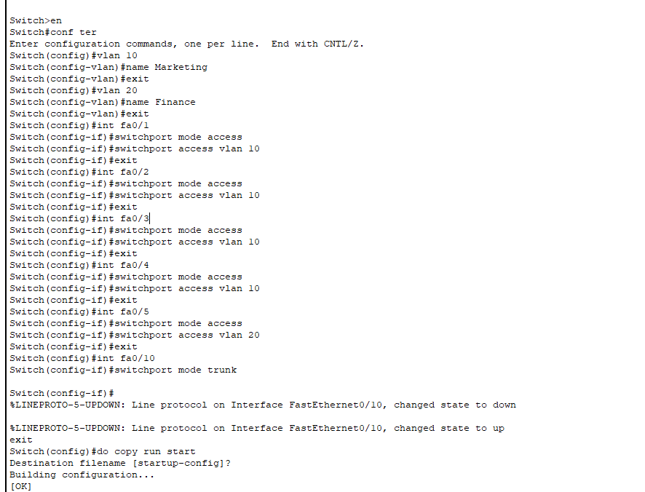

**Commands used to configure Switch2:**

**Appendix D**

Switch1>en

Switch1#conf ter

Switch1(config)# int fa0/24

Switch1(config-if)# switchport access vlan 99

Switch1(config-if)# exit

Switch1(config)# int vlan 99

Switch1(config-if)# ip address 192.168.1.41 255.255.252

Switch1(config-if)# no shut

Switch1(config-if)#exit

Switch1(config)# ip domain-name antonela.com

Switch1(config)# crypto key generate rsa

Switch1(config)# ip ssh version 2

Switch1(config)# int fa0/24

Switch1(config-if)# switchport mode access

Switch1(config-if)# switchport port-security maximum 1

Switch1(config-if)# switchport port-security violation restrict

Switch1(config-if)# switchport port-security mac-address 00D0.D3AE.3A6B

Switch1(config-if)# exit

Switch1(config)# do copy run start